Notes on S3
* 5GB is free for free tier account - for all region except AWS GovCloud region.
*20,000 GET(data retrieval) request and it is charged per GB & 2,000 PUT(changes or modifies) request
*15 GB of data transfer in & 15 GB of data transfer out /month/year
What is S3???
(Simple Storage Service)

- S3 provides developers and IT Teams with Secure, Scalable, Durable object storage.
- Amazon S3 is easy to use with a simple web services interfaces to store and retrieve any amount of data from anywhere on the web.

- S3 is a safe place to store your files.
-It is object based storage.
-The Data is spread across multiple devices and facilities.

Basics of S3 are as below

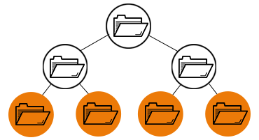
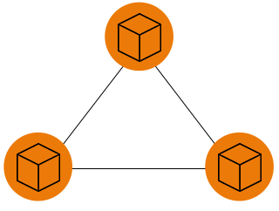
- SE is Object-Based i.e. allows you to upload files.
****Difference between data types ?
- File Storage
- Block Storage
- Object Oriented Storage
* File storage
- Data is stored as a single piece of
information inside a folder, just like
you’d organize pieces of paper inside a
regular folder
- When you need to access that piece of data,
your computer needs to know the path to find it.
- It’s like a library card catalog for data files.
- - It is hierarchy storage form & works as (NAS)network attached storage.
* Block Storage
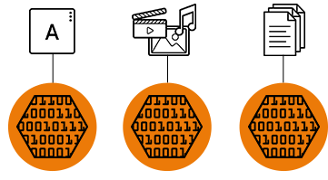
- Block storage cuts data into separate pieces &
each block of data is given as unique identifier.
- some blocks can be stored in linux as well as windows.
- Software resembles data whenever require & it is
basically deployed in storage-area network(SAN) environment
* Object oriented Storage
- Object storage, also known as object-based storage,
Is a flat structure in which files are broken into pieces
and spread out among hardware.
- In object storage, the data is broken into discrete
units called objects and is kept in a single repository,
instead of being kept as files in folders or as blocks on servers.
- To retrieve the data, the storage operating system uses
the metadata and identifiers, which distributes the load better
and lets administrators apply policies that perform more robust searches.
- Object storage requires a simple HTTP application programming interface (API), which is used by most clients in all languages.
- Object storage is cost efficient: you only pay for what you use
- Files can be from 0 bytes to 5TB.
- There is unlimited storage.
- Files are stored in Buckets.
* What is Bucket - Just like folder , you can upload any file???

- S3 is *universal namespacd.*. That means names must be unique globally.
- https://dineshnetleap.s3.amazonaws.com/
-https://dineshbetleap.eu-west-1.amazonaws.com/
- Bucket name must be unique because it works on dns name
- When you upload a file to SE, you will receive a HTTP 200 code if the upload was successful.

S3 is object based. Think of Objects just as files.
Objects consist of the following.:
- Key ( Thus is simply the name of the object )
- Value ( This is simply the data and is made up of a sequence of bytes).
- Version ID (Important for versioning)
- Metadata (Data about data you are storing)
Subresources:
- Access Control Lists
- Torrent
How does data consistency work for S3 ?
- Read after write consistency for PUTS of new object.
- Eventual consistency for overwrite PUTS and DELETES (can take some time to propagate)
***In other words
- if you write a new file and read it immediately afterwards, you will be able to view that data.
- If you update AN EXISTING file or delete a file and read it immediately, you may get the older version, or you may not. Basically changes to objects can take a little bit of time to propagate.

S3 Guarantees
- Built for 99.99% availability for the S3 platform.
- Amazon guarantee 99.9% availability
- Amazon guarantee 99.99999999999% durability for S3 info.

S3 Features
- Tiered Storage Available.
- Lifecycle Management.
- Versioning.
- Encryption.
-MFA Delete.
- Secure your data using Access Control Lists (ACL) permissions.
S3 Storage Classes
- S3 Standard
- 99.99% availability
- 99.99999999999% durability,
- stored redundantly across multiple devices in multiple facilities.
- S3-IA (Infrequently Accessed)
- For data that is accessed less frequently, but requires rapid access when needed.
- Lower fee than S3, but you are charged a retrieval fee.
- S3 One Zone - IA
- For where you want a lower cost option for infrequently accessed data, but do not require the multiple Availability zone data resilience.
- S3 - Intelligent Tiering
- Designed to optimized costs by automatically moving data to the most cost- effective access tier, without performance impact or operational overhead.
- S3 Glacier
- S3 glacier is secure, durable and low cost storage for data archiving. You can reliably store any amount of data at costs that are competitive with or cheaper than on-premises solutions. Retrieval times configurable from minutes to hours.
- S3 Glacier Deep Archival
-S3 glacier deep archival is amazon S3’s lower cost storage class where a retrieval time is acceptable.
S3 Charges
-Storage
-Requests
-Storage Management Pricing
- Data Transfer pricing
-Transfer Acceleration
-Cross Region Replication Pricing.
S3 Transfer Acceleration
- Amazon S3 transfer Acceleration enables fast, easy and secure transfers of files over long distances between your end users and an S3 Bucket.
- Transfer Acceleration takes advantage of Amazon CloudFront’s Globally distributed edge locations. As the data arrives at an edge locations, data is routed to amazon S3 over an optimized network path.

S3 Exam Tips
- Remember that S3 is Object - Based : I.e. allows you to upload files.
- Files can be from 0 Bytes to 5 TB.
- There is unlimited storage.
- Files are stored in buckets.
- S3 is universal namespace. That is, name must be unique globally.
- https://netleapdinesh.s3.amazonaws.com/
-https://netleapdinesh.eu-west-1.amazonaws.com/
- Not suitable to install an operating system on.
- Successful uploads will generate a HTTP 200 status code.
- You can turn on MFA delete.

